CANTERBURY CRICKET 1952/53

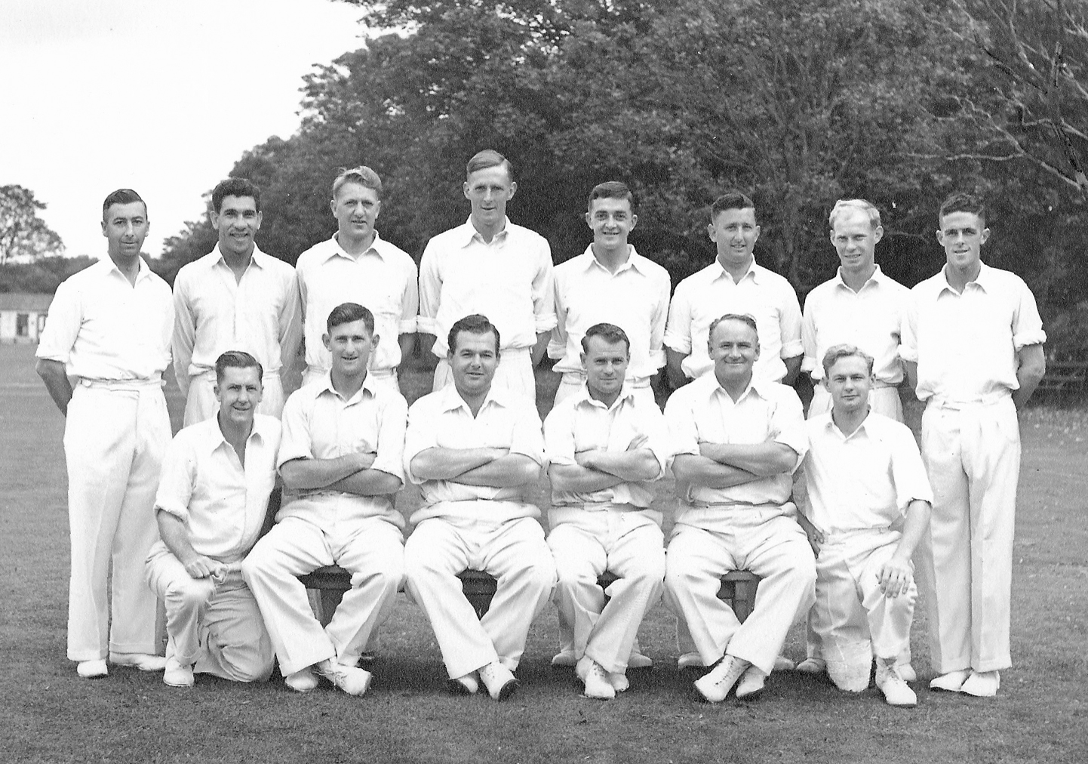

**Back row:** AEL Britton, SC Guillen, KJ McNicholl, AR MacGibbon, JL Williams, ME Chapple, MB Poore, N Bennett

**Front row:** TD Moynihan, JA Hayes, JG Leggat (joint captain), FB Smith (joint captain), TB Burtt, GE Royfee